Welcome!
Date
Name
Spouse
Address
City
State Zip _________
Email

Please Contact By
❑ Card  Phone  Visit

Telephone Best Time to Call
Home ______________
Work ______________

Guest: First Time Second Time
Are you a church member: yes no
Church
City, State

Circle Appropriate Age/Grade Group(s)
Preschool: Ages: B-1 2-3 4-5
Children: Grades: K 1 2 3 4 5 6
Youth: Grades: 7 8 9 10 11 12
Adults: Ages:18-29 30s 40s 50s 60s+

How did you learn about our church?
Newspaper Friend Yellow Pages Mail
Other

I am a guest of:

New in the Community? Yes No
Names & ages of children at home

Weekly Service & Activity Schedule
January 5th, 2014
9:45 a.m. Sunday School
11 a.m. Morning Worship

5 p.m. CHURCH COUNCIL MEETING – Fellowship Hall
5 p.m. Kids in Action
6 p.m. Evening Services

Week of January 6 - 11

Wednesday, 6:30 p.m. Youth Activities
Wednesday, 6:45 p.m. Adult Prayer & Bible Study
Wednesday, 7:30 p.m. Praise Team Rehearsal
Thursday, 10:00 a.m. Adult Fellowship
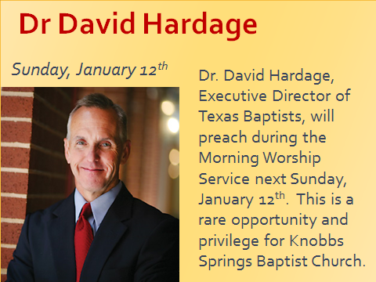
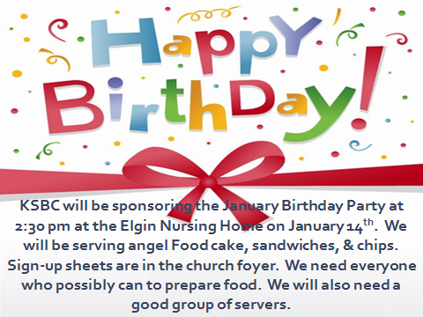

Upcoming Events

January
12 Dr. David Hardage (Covered Dish Luncheon following)
12 Business Meeting
14 Elgin Nursing Home Birthday Celebration
16 Assoc Meeting Somerville Fish Fry
23 Adult Fellowship
25 My Hope America (Deacons)
26 Baptist Men’s Day (Men’s Service)

Note: Beginning this month Birthday & Anniversary Recognitions will occur on the final Sunday Morning of each month.
Knobbs Springs Baptist Church

These are the things God has revealed to us by his Spirit.
The Spirit searches all things, even the deep things
of God. For who knows a person’s thoughts
except their own spirit within them?
In the same way no one knows the thoughts of God
except the Spirit of God. What we have received is not
the spirit of the world, but the Spirit who is from God,
so that we may understand what God has freely given us.
This is what we speak, not in words taught us by human
wisdom but in words taught by the Spirit,
explaining spiritual realities with Spirit-taught words.
The person without the Spirit does not accept the things
that come from the Spirit of God but considers them
foolishness, and cannot understand them because
they are discerned only through the Spirit.
The person with the Spirit makes judgments about
all things, but such a person is not subject to merely
human judgments, for, “Who has known the mind of the Lord so as to instruct him?” But we have the mind of Christ. Brothers and sisters, I could not address you as
people who live by the Spirit but as people who are
still worldly—mere infants in Christ. I gave you milk,
not solid food, for you were not yet ready for it.
Indeed, you are still not ready. You are still worldly.
For since there is jealousy and quarreling among you,
are you not worldly? Are you not acting like mere
humans? For when one says, “I follow Paul,” & another, “I follow Apollos,” are you not mere human beings?

1 Corinthians 2:10 – 3:4

January 5, 2014

Church Information:
KnobbsSpringsBC.com KnobbsSpringsBaptist@gmail.com
1662 CR 305, McDade, Texas 78650 512-273-2743
Brother Dwight Reagan 512-247-6448
Kimberly Tabor, Office Manager 512-698-2804

